BHARATHI WOMEN’S COLLEGE(A)

CHENNAI-600108

JOB APPLICATION TRACKING SYSTEM

|  |  |  |
| --- | --- | --- |
| **REG.NO** | **NAME** | **EMAIL ID** |
|  | **TEAM LEADER** |  |
| 2013331012010 | GEETHA.G | Skgeetha14777717vinayagar@gmail.com |
|  | **TEAM MEMBERS** |  |
| 2013331012014 | JENIFER.D | jeniferdesappan847@gmail.com |
| 2013331012017 | KAVITHA.S | kavirenu1103@gmail.com |
| 2013331012018 | KEERTHIKA.D | keerthikad29@gmail.com |

**OBJECTIVE:**

**✨**JOB APPLICATION TRACKING SYSTEM (JATS) is a software we can use this through the Salesforce application.

✨The JATS is a software application that helps you manage the entire recruitment process, right from receiving resumes to hiring employee codes.

**1.INTRODUCTION**

* 1. **OVERVIEW:**

✨ The job applicant tracking system (JATS) is software that manages the recruiting and hiring process, including job postings and job applications. It organized information about job seekers and makes it searchable.

✨As its name implies, JATS tracks candidates through the hiring process.

✨shortlisting candidates, applicant evaluation, scheduling interviews, managing the hiring process, background verification, and completing new-hire paperwork.

**2.PROBLEM DEFINITION & DESIGN THINKING**

**2.1 EMPATHY MAP**

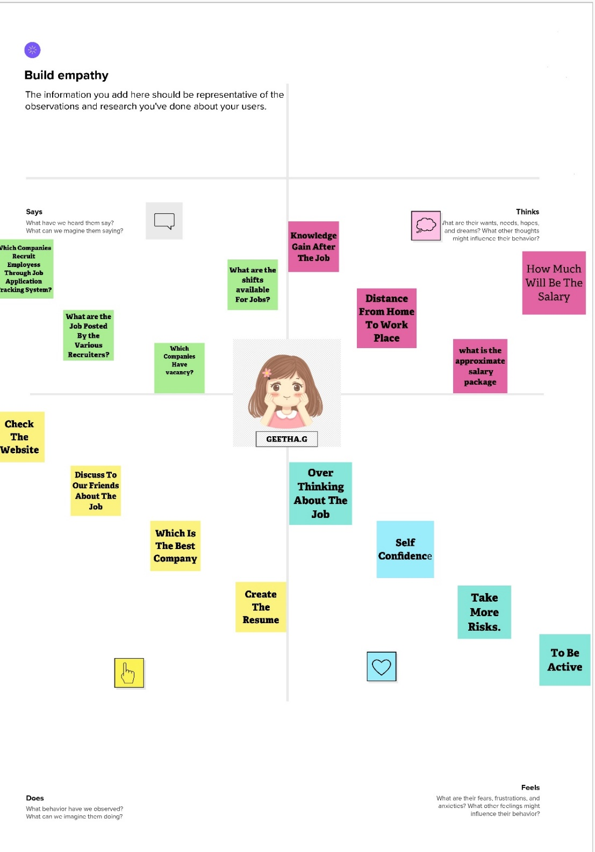

**2.2 IDEATION & BRAINSTORMING MAP**

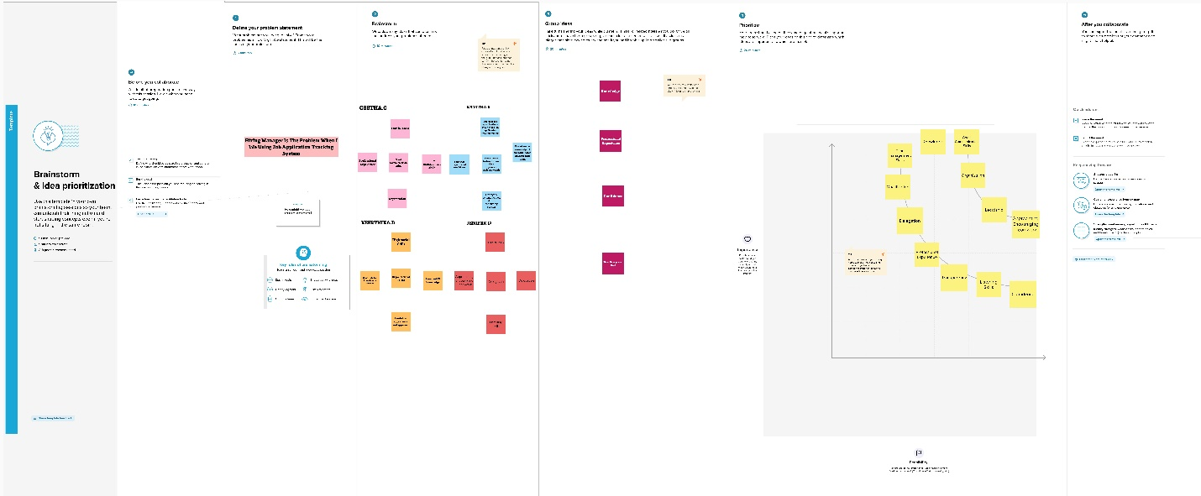

**3.RESULT**

**3.1 DATA MODEL:**

|  |  |
| --- | --- |
| **OBJECT NAME** | **FIELDS IN THE OBEJECT** |
| Object 1 | |  |  | | --- | --- | | **Field label** | **Data type** | | Recruiter | Auto Number | | Job | Text | |
| Object 2 | |  |  | | --- | --- | | **Field label** | **Data type** | | Recruiter | Master -Detail Relationship | | Description | Text Area | |

**3.2 ACTIVITITY & SCREENSHOT WITH DESCRIPTION**

**MILESTONE 1- Salesforce:**

**Activity 1**

**Creating a Salesforce Developer Org:**

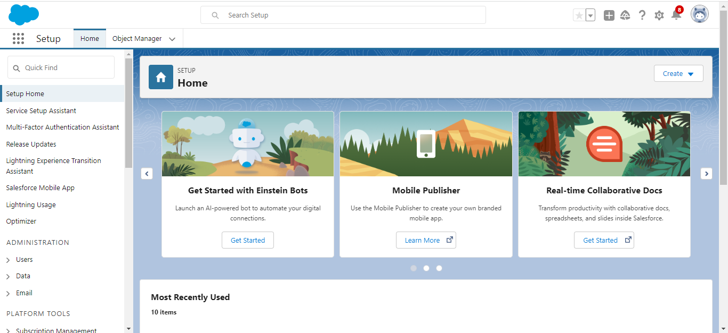

**DESCRIPTION**

1. Search Developer.salesforce.com

2.Enter the following details like First name, last name, Email, Role, Company, Country/Region, Postal code, and Username must be unique.

3. Click sign me up, after a few min you will reserve a mail salesforce org and by using the verify account link you can create your new password

4. Click save.

5.Search login.salesforce.com

6. By using username and password you can into the salesforce org.

**MILESTONE 2- Object:**

**Activity 1:**

**Create a Custom Object for Recruiter:**

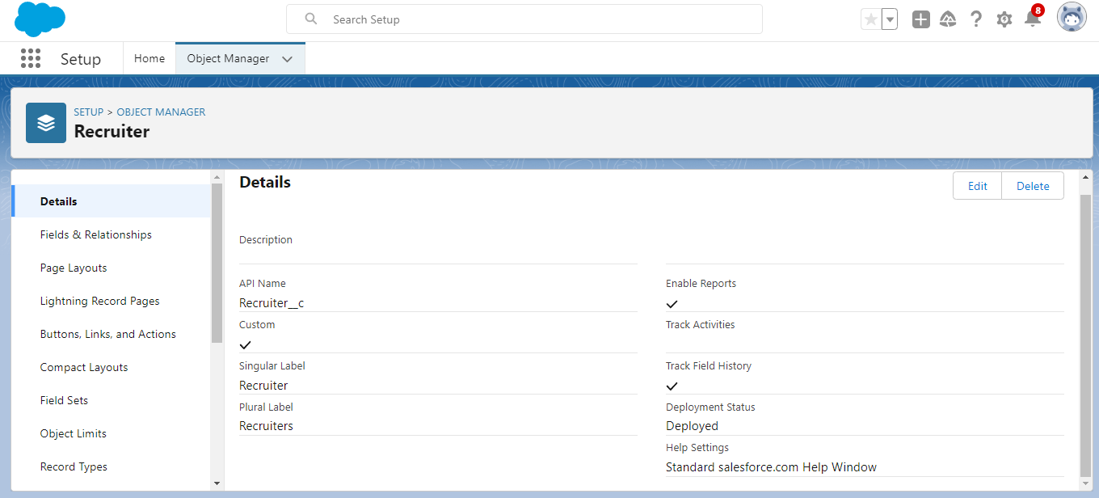

**Activity 2:**

**1.Creat a Jobs, Candidate, Job Application Object and Tab.**

**Jobs**

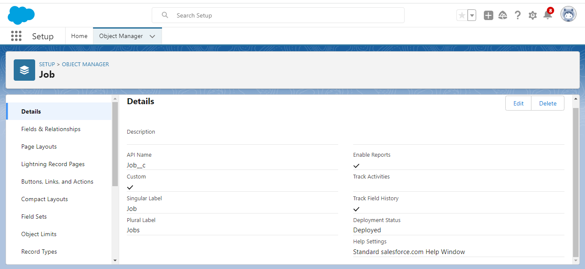

**Candidate**

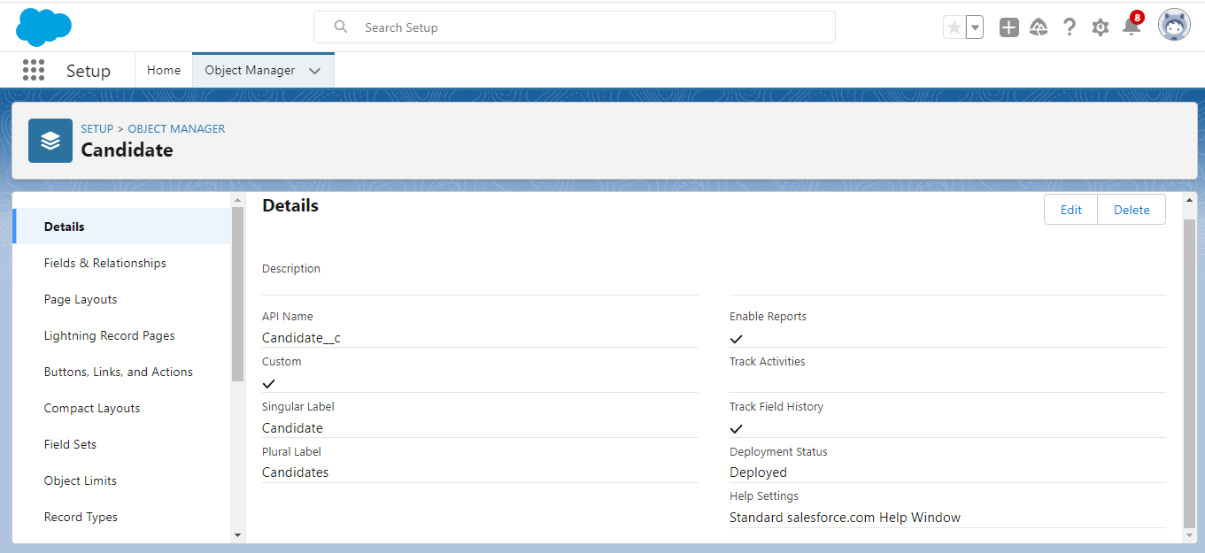

**Job Application**

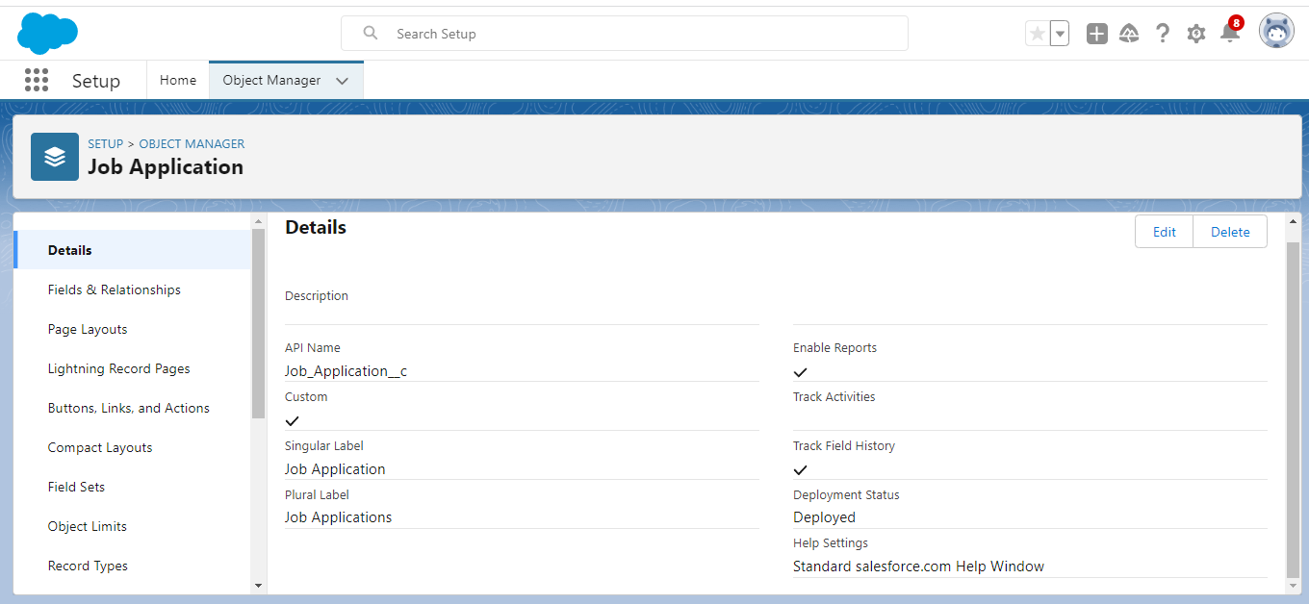

**Object**

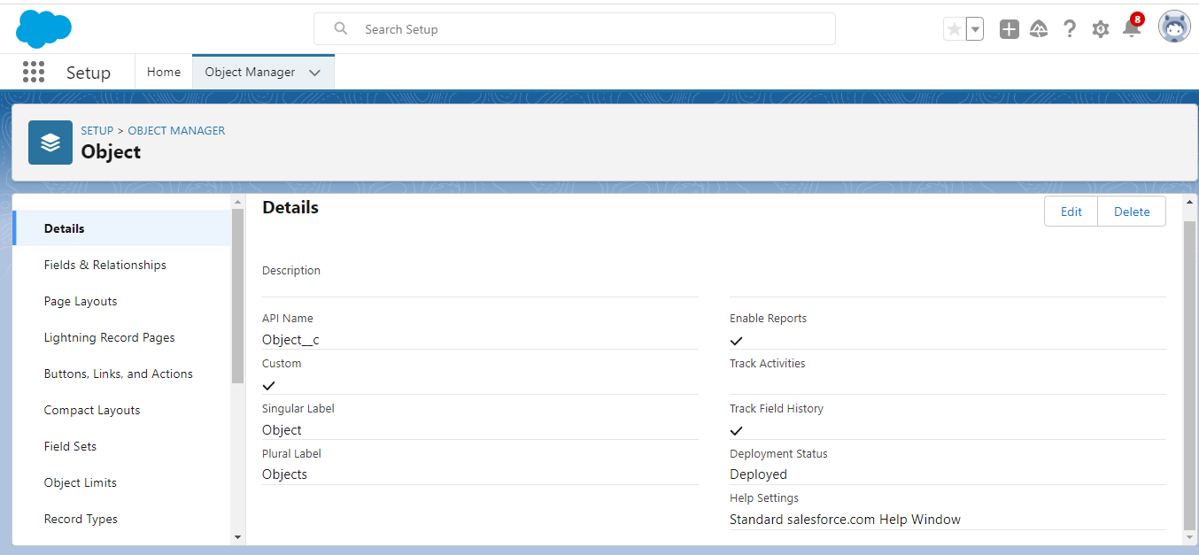

**Tab**

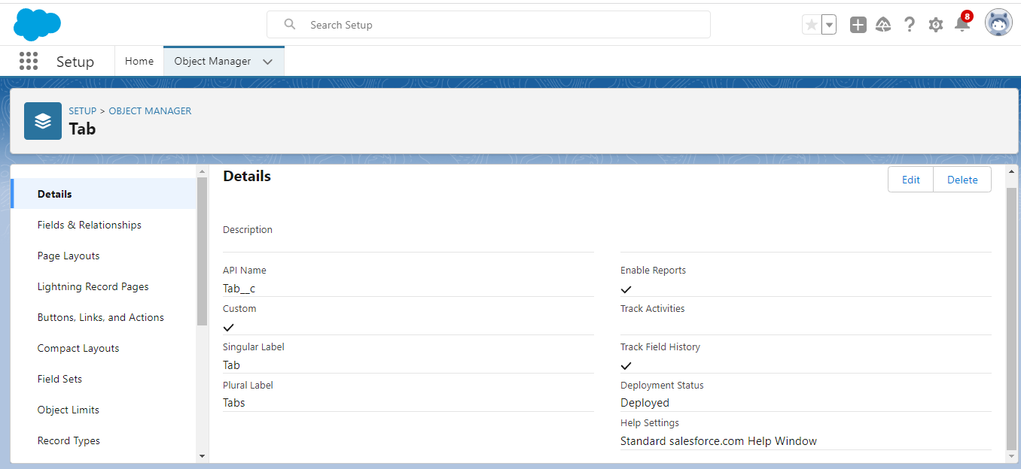

**DESCRIPTION:**

To create a custom object, follow these steps:

1. From setup click on object manager.

2. Click create, select custom object.

3. Fill in the label as " Recruiter ".

4. Fill in the plural label as " Recruiters"

5. Record name: " Recruiter Number"

6. Select the data type as "Auto Number".

7. Under display format enter "REC-{0000}".

8. Enter starting number as 1.

9. In the Optional Features section, select Allow Reports and Track Field History.

10. In the Deployment Status section, ensure Deployed is selected.

11. In the Search Status section, select Allow Search.

12. In the Object Creation Options section, select Add Notes and Attachments related list to default page layout.

**Milestone 3- Fields:**

**Activity 1:**

**Create the custom fields**

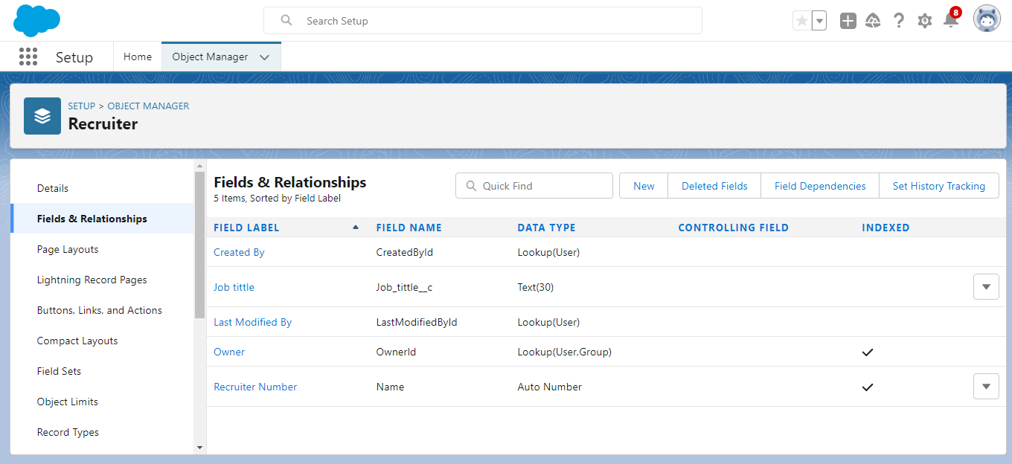

**Activity 2:**

**Creation of Master-detail relationship**

**Activity 3:**

**Create a new custom field:**

**Activity 4:**

**Create a new custom field:**

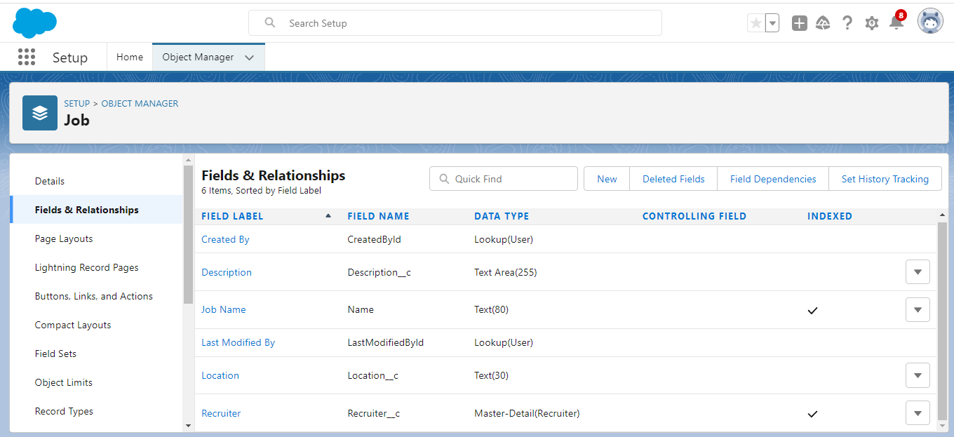

**DESCRIPTION:**

1.Click the object manager tab, Select the object for which you have to create the fields and relationships.

2.From the sidebar, click Fields & Relationships. Notice that there are already some fields there Those are the standard fields.

3. Click New to create a custom field. Tip: Before creating a new field, do a quick search to make sure a similar one doesn’t already exist.

4. Click on the new to create a field.

5.Choose the data type as a Text, click next

6.Enter field label, length and Name and click next

7.Select the profiles to which you want to grant edit access to this field via field-level security. The field will be hidden from all profiles if you do not add it to field-level security. Click next

8.Select the page layouts that should include this field.

9.Click save.

**Milestone 4-Tab:**

**Activity 1:**

**Create a Tab**

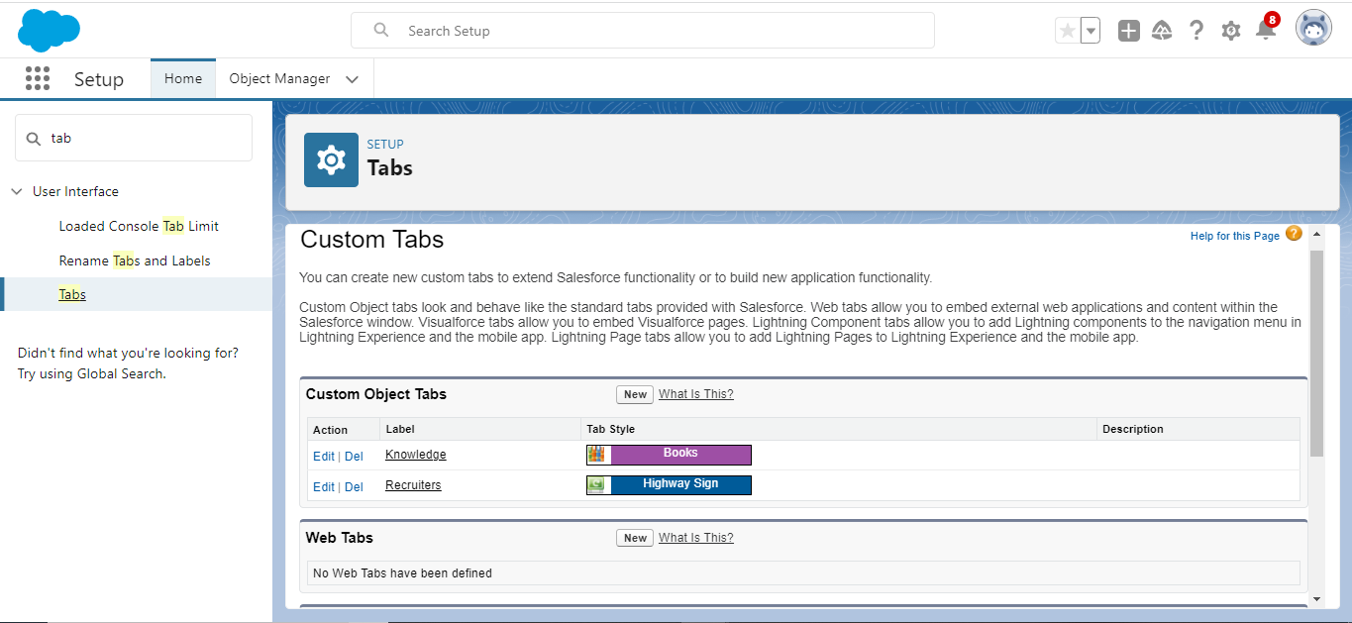

**DESCRIPTION:**

1. Click setup

2. Search tab in Quick box then, select tab

3. Click New custom object tab section

4. Select the created object Recruiter and tab style for the new custom tab.

5. Select the profiles that visible in the tab

6. Click on custom apps to make visible.

7. Click save.

**Milestone 5- Profile:**

**Activity 1:**

**Create a custom profile**

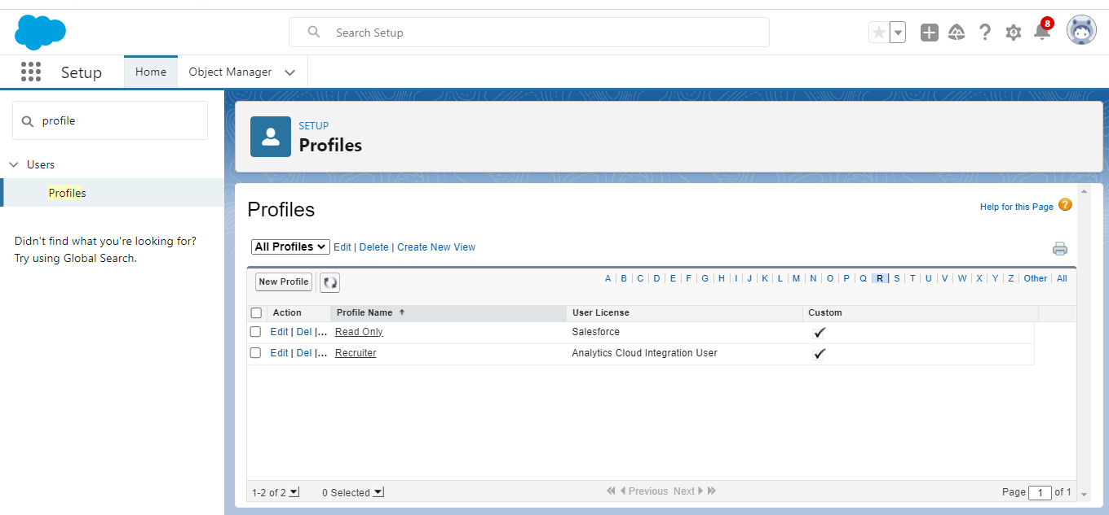

**Activity 2:**

**Create a profile with the profile name as “Sales Manager”. Follow the steps from above Activity**

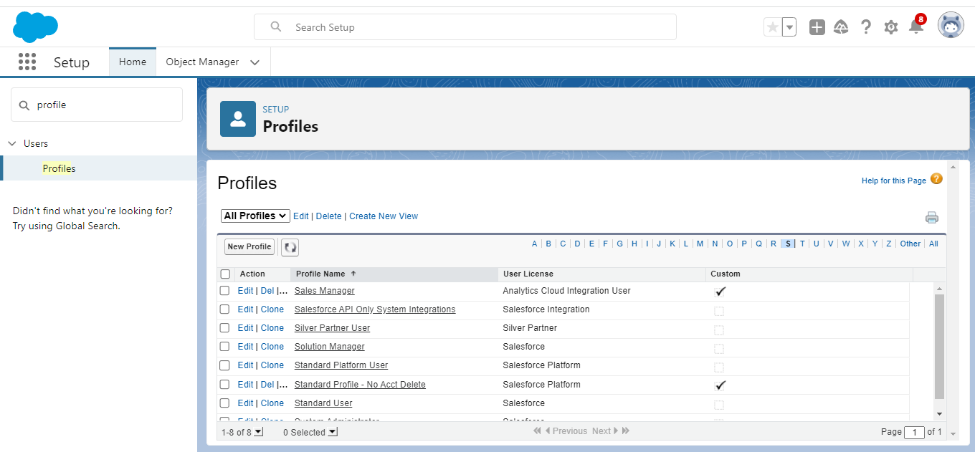

**DESCRIPTION:**

1. From setup , enter profiles in Quick Find box

2. Select profiles.

3. Click clone.

4. For Profile, enter Recruiter.

5. Click save.

**Milestone 6-User**

**Activity 1:**

**To Create a user:**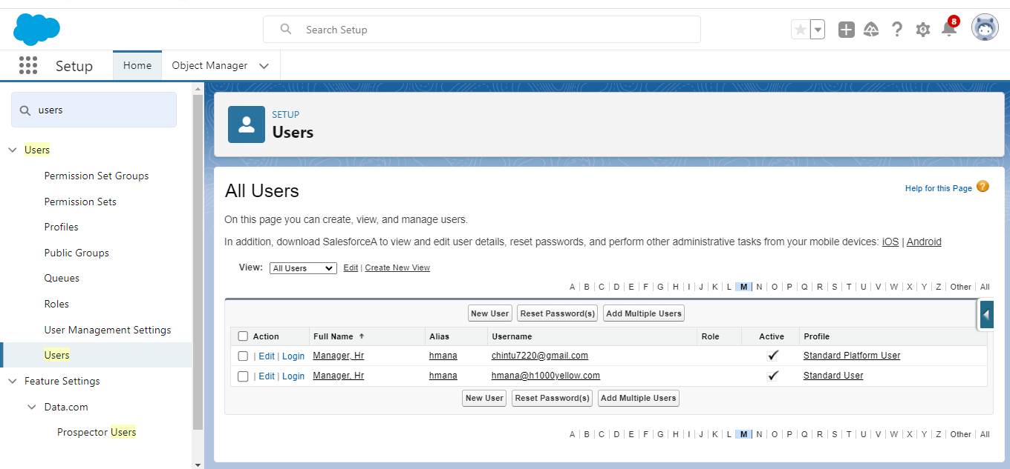

**Activity 2:**

**Create a user with a username as “Ganesh Gelli”, and assign him the sales Manager profile. Follow the steps from above Activity**

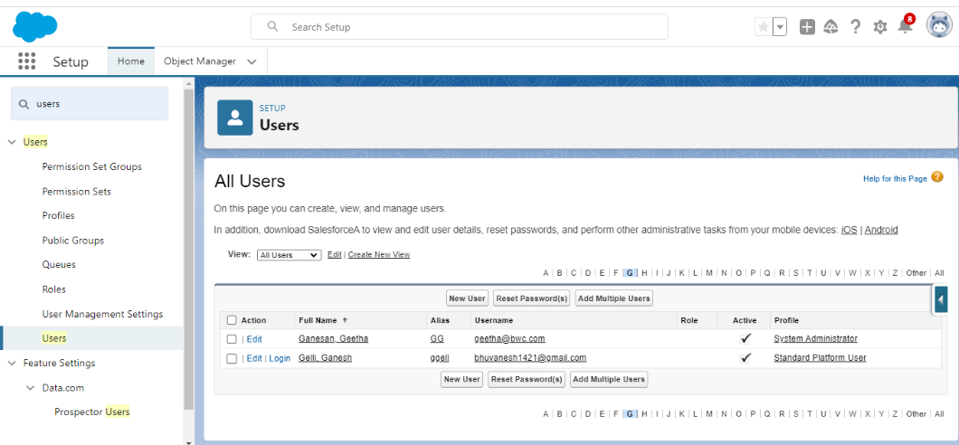

**DESCRIPTION:**

1. From Setup, enter Users in the Quick Find box, then select Users.

2. Click New User.

3. Enter First name as HR and last name as Manager

4. Enter the user’s name and email address and a unique username in the form of an email address. By default, the username is the same as the email address.

5. Then create a new role HR Manager.

6. Select user License as Standard Platform User.

7. Select profile.

8. Click save.

**Milestone 7-Sharing Rules:**

**Activity 1:**

**Create a sharing rule**

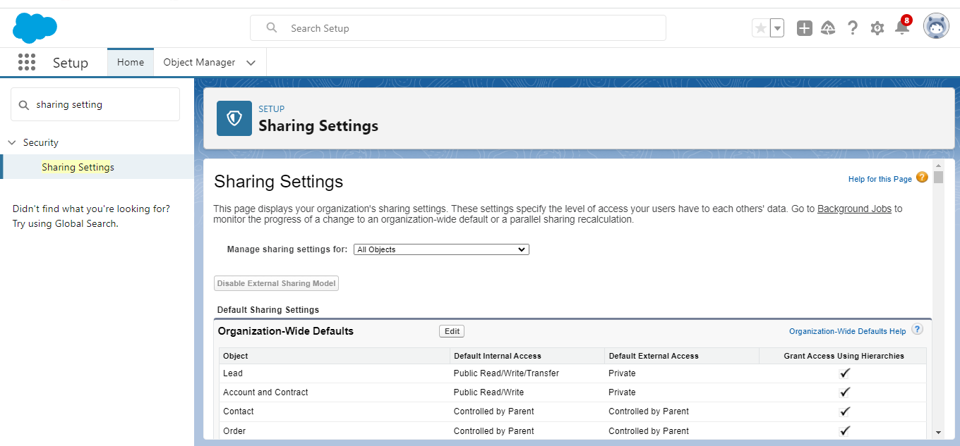

**Activity 2:**

**Create a Sharing Rule to Share the records of Job Application to HR Manager with the Access of Read/Write.**

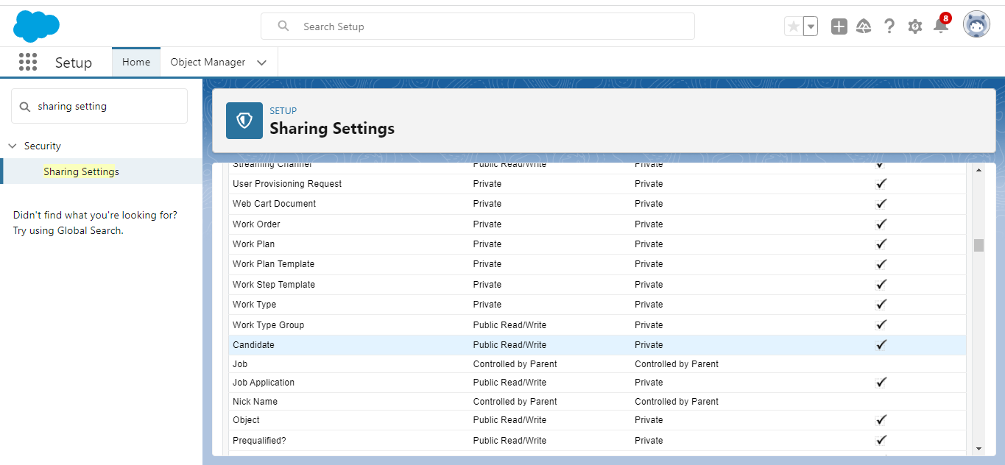

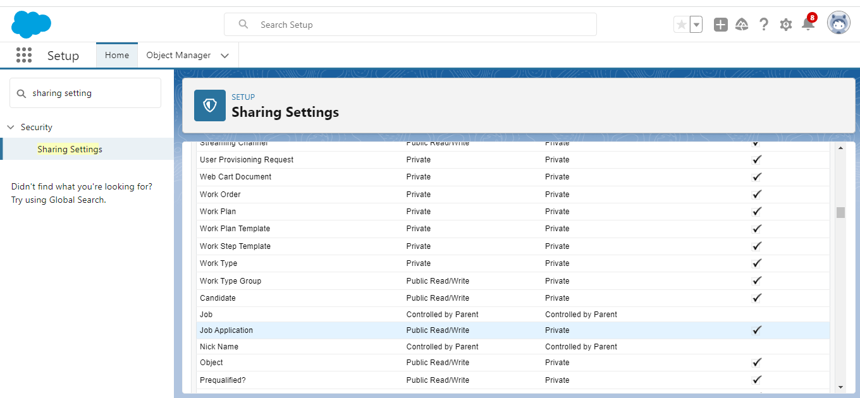

**DESCRIPTION:**

1. Go to Sharing Settings, which can be found under the Quick Find section
2. Scroll down and find the candidate object where a sharing rule needs to be added, and then click on New to create a new sharing rule

3) Add the label of the sharing rule you want to make.

4) Select your rule type based on the criteria.

5) Select the field can join immediately check field from the candidate object.

6) Select the operator as equal and value is true.

7) And in selecting the users to share with the section select roles and in that select Hr Manager.

8) And in the section of select the level of access for the users give the access Read/Write.

9) And save the rule.

**Milestone 8-Reports:**

**Activity 1:**

**Create a report:**

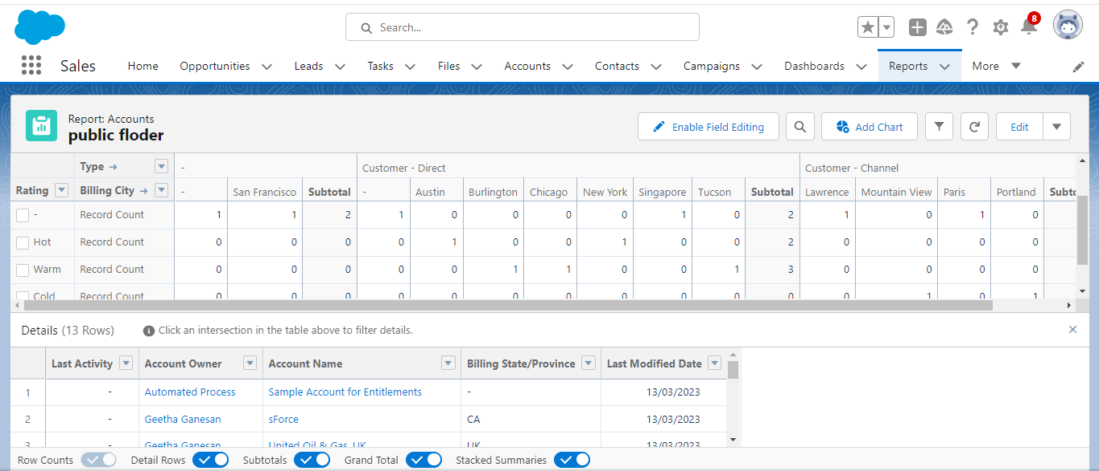

**Activity 2:**

**Create a Report using the Objects Jobs, Candidate and Job Application. Follow the steps from above Activity.**

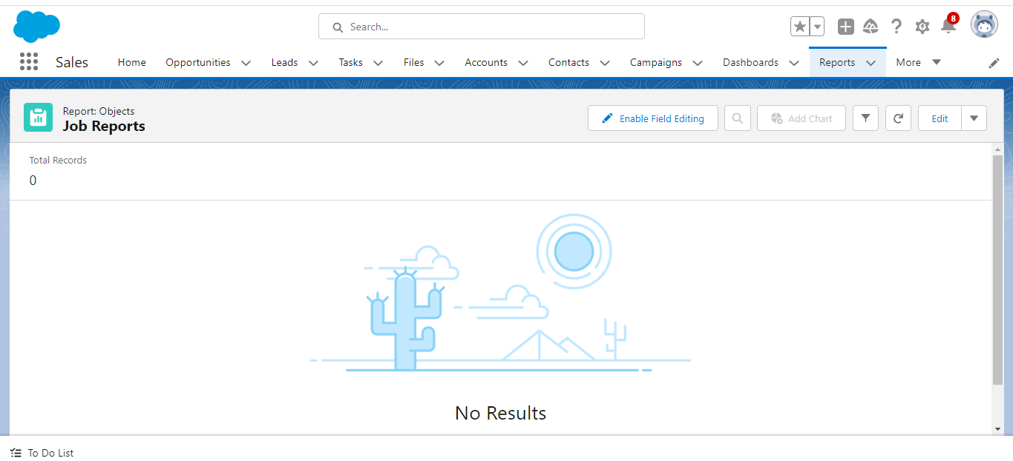

**DESCRIPTION:**

Create a report that displays rating of the account and which has type and account name.

1) Click on app launcher search for reports.

2) Click on the new report and select the category has accounts and contacts.

3) And the report type has accounts.

4) In the details section select the option start report.

5) In the filter pane select All accounts to show me.

6) And All time is created.

7) In the outline pane, group rows select Rating and in group columns select Account Name.

8) In the columns section add Type and Billing city.

**4. TRAILHEAD PROFILE PUBLIC URL**

**TEAM LEAD –** https://trailblazer.me/id/geetg14

**TEAM MEMBER** - https://trailblazer.me/id/djenifer123

**TEAM MEMBER** - https://trailblazer.me/id/kavis102

**TEAM MEMBER** - https://trailblazer.me/id/keerd11

**PROJECT REPORT TEMPLATE**

**5.ADVANTAGES & DISADVANTAGE**

**ADVANTAGES:**

Job application tracking system advantages include enabling you to focus more on tasks that truly require your attention rather than spending manual resources on routine, mundane tasks.

Good JATS can save almost 50% of your time by automating these routine tasks. In doing so, your processes get more efficient and faster.

**DISADVANTAGE:**

Could filter out good candidate.

Communication can be less personalized.

Takes more time to train an external candidate.

Damage employee morale.

**APPLICATIONS:**

**Managing the candidates**: JATS is a tool for managing the candidate resume, evaluation and hiring process from start to finish.

**Handles the recruitment process:** JATS software handles the recruitment process just by sorting through thousands of applications, to determine, which ones are the best fit for the jobs for which they were submitted.

**Score Candidate:** Job applicant tracking software may score candidates and rank more qualified applicants based on the employer's standards.

**To post job opening:** Job application tracking software can be used to post job opening on a corporate website or job board and create interview requests to likely candidate through email.

**7. CONCLUSION**

JATS are crucial for streamlining and automating your hiring process and assisting you in becoming more productive and efficient in your daily responsibilities.

They also improve the hiring process, reduce the burden, and boost candidate experience.

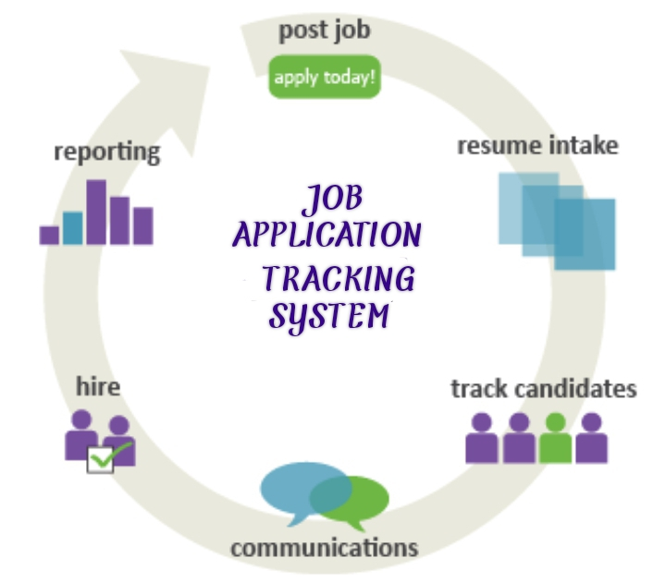

**8.FUTURE SCOPE**

**Modern Job Application Tracking System:** It has become extremely easy for an HR leader to stay up to date.

**JATS have become more user-friendly:** With the help of JATS, HR professionals can easily create efficient workflows and keep a constant check on the hiring process without any difficulty.